JAVA HACKATHON-1
Name: Eshanth
Roll.No. : 2620030131
Section: 15
Q3A)Write a Java program to store and display the following details of a waste collection vehicle:
- Vehicle number – integer
- Waste collected in kilograms – decimal value
- Number of collection points – integer
- Vehicle status – character
Use appropriate Java data types for each value and display all the details.
CODE:
public class Wastemunicipal {
public static void main(String[] args) {
int vehicleNumber = 7439;
double wasteCollected = 90.5;
int collectionPoints = 9;
char vehicleStatus = 'A';

System.out.println("Waste Collection Vehicle Details");
System.out.println("Vehicle Number: " + vehicleNumber);
System.out.println("Waste Collected: " + wasteCollected);
System.out.println("Number of Collection Points: " + collectionPoints);
System.out.println("Vehicle Status: " + vehicleStatus);
}
}
OUTPUT:
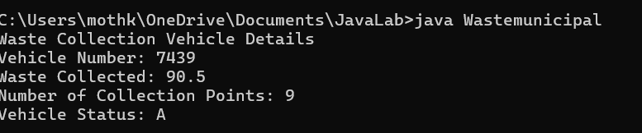
Q3B) Write a Java program to check the waste collection status based on the amount of waste collected. Read the waste collected in kilograms.
- If the waste collected is 100 kg or more, display "Collection Target Achieved".
- Otherwise, display "More Waste Collection Required".
Use an if-else statement.
CODE:
import java.util.Scanner;

class Main1 {
public static void main(String[] args) {
Scanner sc = new Scanner(System.in);

System.out.print("Enter waste collected in kg: ");
double waste = sc.nextDouble();

if (waste >= 100) {
System.out.println("Collection Target Achieved");
}
else {
System.out.println("More Waste Collection Required");
}
sc.close();
}
}
OUTPUT:
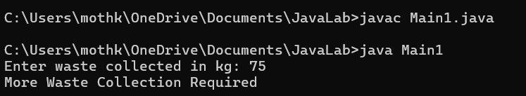
Q3C)Write a Java program to calculate the total waste collected from two collection points using a method.
Create the following method:
calculateTotalWaste(double point1Waste, double point2Waste)
The method should return the total waste collected. Read the waste collected at the two collection points from the user, call the method, and display the total waste collected.
CODE:
import java.util.Scanner;
class Main2 {
static double calculateTotalWaste(double point1Waste, double point2Waste) {
return point1Waste + point2Waste;
}
public static void main(String[] args) {

Scanner sc = new Scanner(System.in);
System.out.print("Enter waste at point 1: ");

double a = sc.nextDouble();
System.out.print("Enter waste at point 2: ");

double b = sc.nextDouble();
double total = calculateTotalWaste(a, b);
System.out.println("Total waste collected: " + total);
}
}
OUTPUT:
